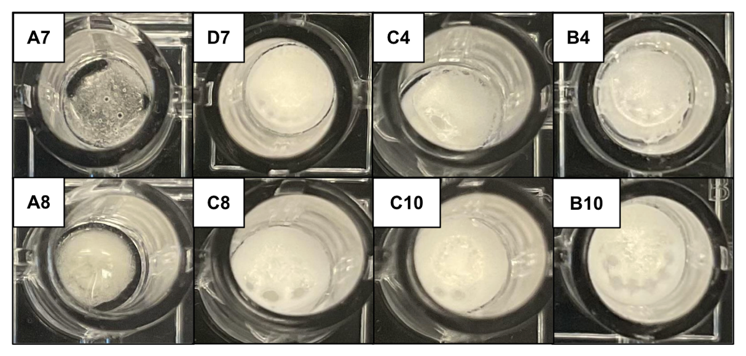
Supplementary Figure 1. Images of lyo formulations that yield undesirable cake appearance: wells A7, D7, C4, B4, A8, C8, C10, and B10
This is the appearance of cakes for lyo formulations that have similar chemical compositions to the lyo formulations (B7 mix and C7 mix). Ficoll 400 concentration of at least 2% is necessary to form the ideal lyo cake. The absence of Ficoll 400 resulted in clear and sticky lyo cake (A7 mix and A8 mix). Wells with 10% trehalose (C4 mix and B4 mix) resulted in an opaque white but sticky lyo cake. Other formulations seem to yield opaque white cakes, but they were difficult to rehydrate or produce non-functional crude Taq extract upon rehydration.

